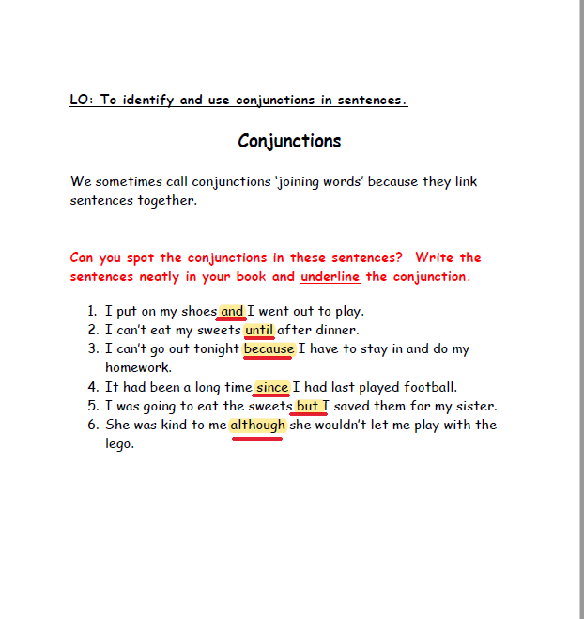

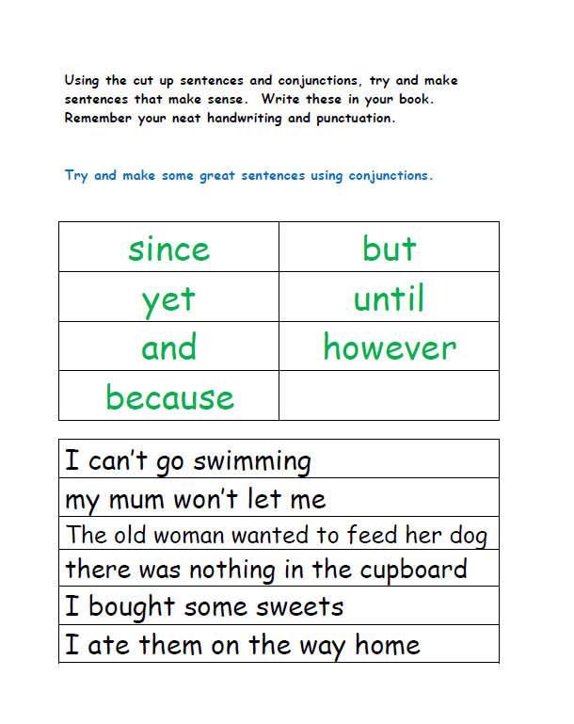

.

1. I can’t go swimming because, I am Sick.

2-

3-The old woman wanted to feed her dog, but there was no food in the cabinet.